What are neurotransmitters?

Neurotransmitters are chemical messengers that your body can’t function without. Their job is to carry chemical signals (“messages”) from one neuron (nerve cell) to the next target cell. The next target cell can be another nerve cell, a muscle cell or a gland.

What body functions do nerves and neurotransmitters help control?

Your nervous system controls such functions as your:

Heartbeat and blood pressure.

Breathing.

Muscle movements.

Thoughts, memory, learning and feelings.

Sleep, healing and aging.

Stress response.

Hormone regulation.

Digestion, sense of hunger and thirst.

Senses (response to what you see, hear, feel, touch and taste).

How do neurotransmitters work?

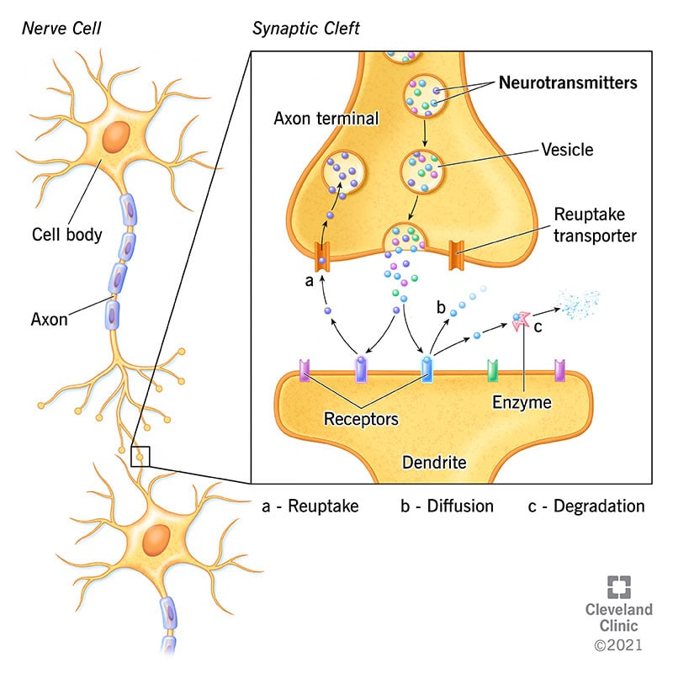

You have billions of nerve cells in your body. Nerve cells are generally made up of three parts:

A cell body. The cell body is vital to producing neurotransmitters and maintaining the function of the nerve cell.

An axon. The axon carries the electrical signals along the nerve cell to the axon terminal.

An axon terminal. This is where the electrical message is changed to a chemical signal using neurotransmitters to communicate with the next group of nerve cells, muscle cells or organs.

Neurotransmitters are located in a part of the neuron called the axon terminal. They’re stored within thin-walled sacs called synaptic vesicles. Each vesicle can contain thousands of neurotransmitter molecules.

As a message or signal travels along a nerve cell, the electrical charge of the signal causes the vesicles of neurotransmitters to fuse with the nerve cell membrane at the very edge of the cell. The neurotransmitters, which now carry the message, are then released from the axon terminal into a fluid-filled space that’s between one nerve cell and the next target cell (another nerve cell, muscle cell or gland).

In this space, called the synaptic junction, the neurotransmitters carry the message across less than 40 nanometers (nm) wide (by comparison, the width of a human hair is about 75,000 nm). Each type of neurotransmitter lands on and binds to a specific receptor on the target cell (like a key that can only fit and work in its partner lock). After binding, the neurotransmitter then triggers a change or action in the target cell, like an electrical signal in another nerve cell, a muscle contraction or the release of hormones from a cell in a gland.

What action or change do neurotransmitters transmit to the target cell?

Neurotransmitters transmit one of three possible actions in their messages, depending on the specific neurotransmitter.

Excitatory. Excitatory neurotransmitters “excite” the neuron and cause it to “fire off the message,” meaning, the message continues to be passed along to the next cell. Examples of excitatory neurotransmitters include glutamate, epinephrine and norepinephrine.

Inhibitory. Inhibitory neurotransmitters block or prevent the chemical message from being passed along any farther. Gamma-aminobutyric acid (GABA), glycine and serotonin are examples of inhibitory neurotransmitters.

Modulatory. Modulatory neurotransmitters influence the effects of other chemical messengers. They “tweak” or adjust how cells communicate at the synapse. They also affect a larger number of neurons at the same time.

Amino acids neurotransmitters

These neurotransmitters are involved in most functions of your nervous system.

Glutamate. This is the most common excitatory neurotransmitter of your nervous system. It’s the most abundant neurotransmitter in your brain. It plays a key role in cognitive functions like thinking, learning and memory. Imbalances in glutamate levels are associated with Alzheimer’s disease, dementia, Parkinson’s disease and seizures.

Gamma-aminobutryic acid (GABA). GABA is the most common inhibitory neurotransmitter of your nervous system, particularly in your brain. It regulates brain activity to prevent problems in the areas of anxiety, irritability, concentration, sleep, seizures and depression.

Glycine. Glycine is the most common inhibitory neurotransmitter in your spinal cord. Glycine is involved in controlling hearing processing, pain transmission and metabolism.

Monoamines neurotransmitters

These neurotransmitters play a lot of different roles in your nervous system and especially in your brain. Monoamines neurotransmitters regulate consciousness, cognition, attention and emotion. Many disorders of your nervous system involve abnormalities of monoamine neurotransmitters, and many drugs that people commonly take affect these neurotransmitters.

Serotonin. Serotonin is an inhibitory neurotransmitter. Serotonin helps regulate mood, sleep patterns, sexuality, anxiety, appetite and pain. Diseases associated with serotonin imbalance include seasonal affective disorder, anxiety, depression, fibromyalgia and chronic pain. Medications that regulate serotonin and treat these disorders include selective serotonin reuptake inhibitors (SSRIs) and serotonin-norepinephrine reuptake inhibitors (SNRIs).

Histamine. Histamine regulates body functions including wakefulness, feeding behavior and motivation. Histamine plays a role in asthma, bronchospasm, mucosal edema and multiple sclerosis.

Dopamine. Dopamine helps with focus, concentration, memory, sleep, mood and motivation. Diseases associated with dysfunctions of the dopamine system include Parkinson’s disease, schizophrenia, bipolar disease, restless legs syndrome and attention deficit hyperactivity disorder (ADHD). Many highly addictive drugs (cocaine, methamphetamines, amphetamines) act directly on the dopamine system.

Epinephrine. Epinephrine (also called adrenaline) and norepinephrine (see below) are responsible for your body’s so-called “fight-or-flight response” to fear and stress. These neurotransmitters stimulate your body’s response by increasing your heart rate, breathing, blood pressure, blood sugar and blood flow to your muscles, as well as heighten attention and focus to allow you to act or react to different stressors. Too much epinephrine can lead to high blood pressure, diabetes, heart disease and other health problems. As a drug, epinephrine is used to treat anaphylaxis, asthma attacks, cardiac arrest and severe infections.

Norepinephrine. Norepinephrine (also called noradrenaline) increases blood pressure and heart rate. It’s most widely known for its effects on alertness, arousal, decision-making, attention and focus. Many medications (stimulants and depression medications) aim to increase norepinephrine levels to improve focus or concentration to treat ADHD or to modulate norepinephrine to improve depression symptoms.

Peptide neurotransmitters

Peptides are polymers or chains of amino acids.

Endorphins. Endorphins are your body’s natural pain reliever. They play a role in our perception of pain. Release of endorphins reduces pain, as well as causes “feel good” feelings. Low levels of endorphins may play a role in fibromyalgia and some types of headaches.

Acetylcholine

This excitatory neurotransmitter does a number of functions in your central nervous system (CNS [brain and spinal cord]) and in your peripheral nervous system (nerves that branch from the CNS). Acetylcholine is released by most neurons in your autonomic nervous system regulating heart rate, blood pressure and gut motility. Acetylcholine plays a role in muscle contractions, memory, motivation, sexual desire, sleep and learning. Imbalances in acetylcholine levels are linked with health issues, including Alzheimer’s disease, seizures and muscle spasms.

Medications can block the enzyme that breaks down a neurotransmitter so that more of it reaches nerve receptors.

Example: Donepezil, galantamine and rivastigmine block the enzyme acetylcholinesterase, which breaks down the neurotransmitter acetylcholine. These medications are used to stabilize and improve memory and cognitive function in people with Alzheimer’s disease, as well as other neurodegenerative disorders.

Medications can block the neurotransmitter from being received at its receptor site.

Example: Selective serotonin reuptake inhibitors are a type of drug class that blocks serotonin from being received and absorbed by a nerve cell. These drugs may be helpful in treating depression, anxiety and other mental health conditions.

Medications can block the release of a neurotransmitter from a nerve cell.

Example: Lithium works as a treatment for mania partially by blocking norepinephrine release and is used in the treatment of bipolar disorder.